5-a-side Tips for coaches
- Squad size should be 12/13 players.
- Football weight (290 U8) (320 U9). Shin guards are mandatory.
- Ensure the retreat line is not encroached when defending.
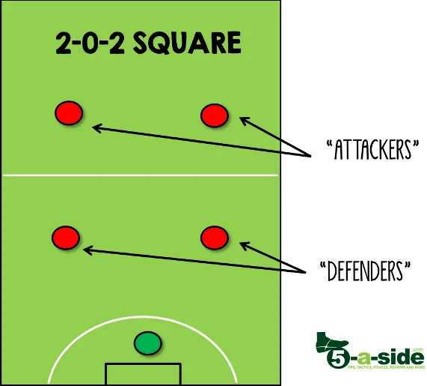
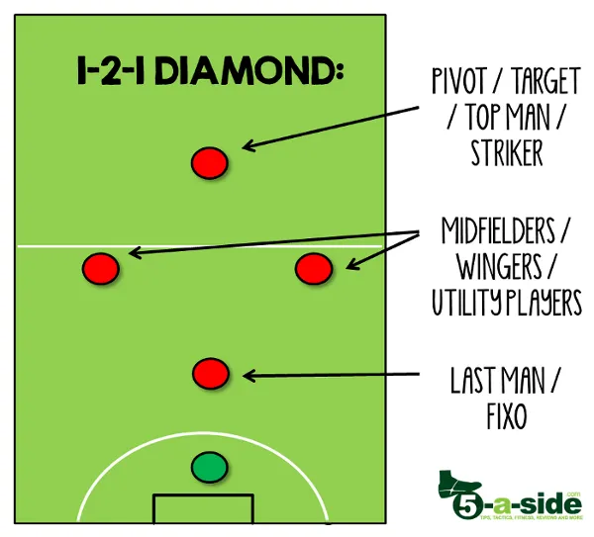
- Match is 4 x 12 mins, each player should get at least 36 mins.
- Roll on, roll off subs, set a timer to remind you or ask an assistant. Rotate the players positions and get all players to play in goal during the season.
- Width, depth & movement for attacking play, make the pitch big.
- When defending press the ball, cover and stay compact. Include goalkeeping positioning.
- Match is supervised, no penalties, no offside, use common sense.
- Don’t over coach, let the players make decisions and learn themselves
- Team formations 1-1-2-1 or 1-2-0-2
https://www.fai.ie/domestic/coach-education/latest#

