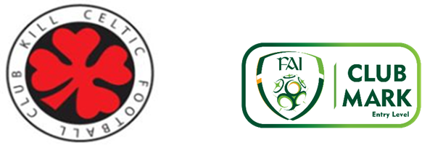

CODE OF CONDUCT FOR PARENTS

CODE OF CONDUCT FOR PARENTS
As a parent of a registered player I agree to the following:
- To remember that children participate in sport for their enjoyment not mine.
- To encourage children to participate, do not force them.
- To focus on the child’s efforts and performance rather than winning or loosing.
- To encourage children always to play according to the rules and settle disagreements without resorting to hostility or violence.
- To never ridicule or yell at a child for making a mistake or loosing a competition.
- To remember that children learn best by example.
- To appreciate good performances and skilful plays by all participants.
- To support all efforts to remove verbal and physical abuse from sporting activities.
- To respect official’s decisions and teach children to do likewise.
- To show appreciation for volunteer coaches, officials and administration – without them my child could not participate.
- To respect the rights, dignity and worth of every young person, regardless of their gender, cultural background, ability or religion.
- If I have a problem with my child I will talk to his coach/manager and arrange to meet them.
- To not discuss other players in public and focus my energies on my child’s development in the long term.
- To support my child’s coach/manager and be proud of my child’s progress at all times.
- To support the club in the long term development of my child and refrain from actions that may impede on the club’s programmes of development..

